Statistics Lecture 3.2: Finding the Center of a Data Set. Mean, Median, Mode

Describing Data
Five Characteristics of Data:
- Center
- Variation
- Distribution
- Outliers
- Changes over time

Center
The Middle of the Data set.
3 ways to compute it.
- Mean: Arithmetic average - add all the values and divide by the number of values.

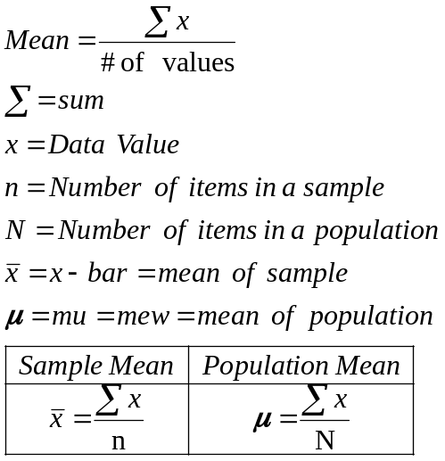.

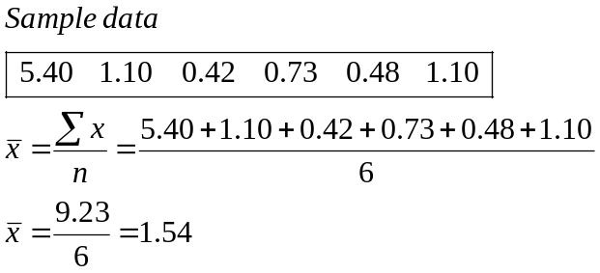

- Median: The middle value of the data set.
Must be in order from smallest to largest.
Find the middle value.
-odd number of data values just take the middle number for the median.
-even number of data values - mean (average) the two middle values.

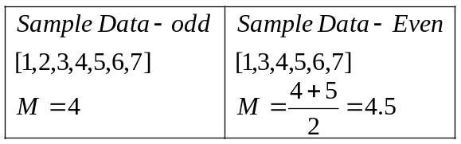

Example
Find the Median
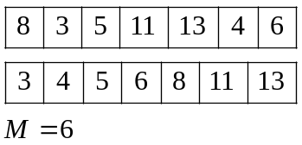
Example
Find the Median
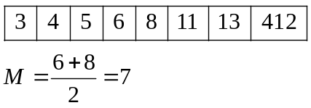
Example
Find the Median
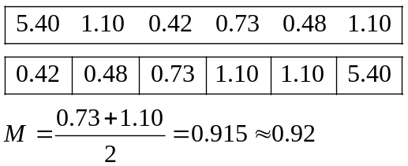
The Median is not affected by outliers but the mean is.
- Mode: The most common occurring data value.
- 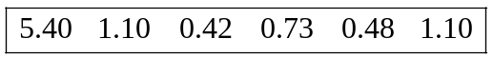 Mode= 1.10
- 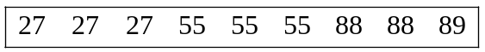 bi-Modal
Modes= 27,55, the maximum repeating elements count
So everything with three of the same elements
Count but not the 88 only in data twice.
- 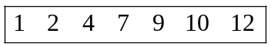 no mode mode =null set

Mean of a frequency distributions
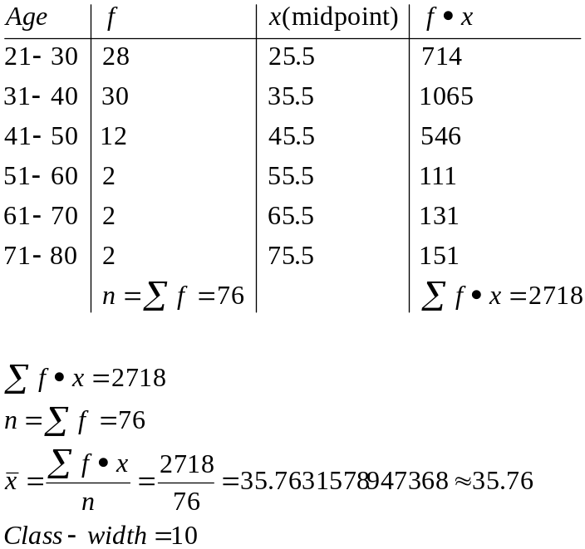

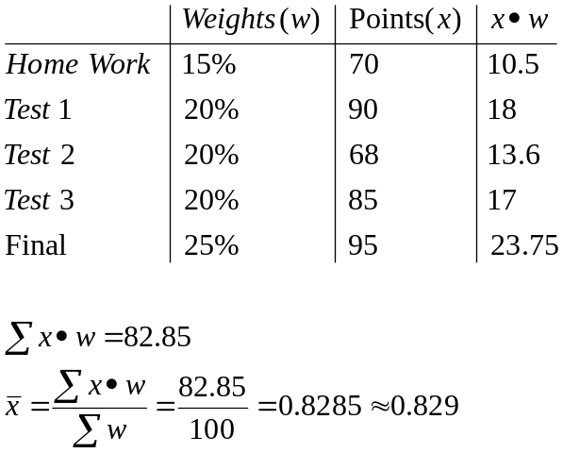

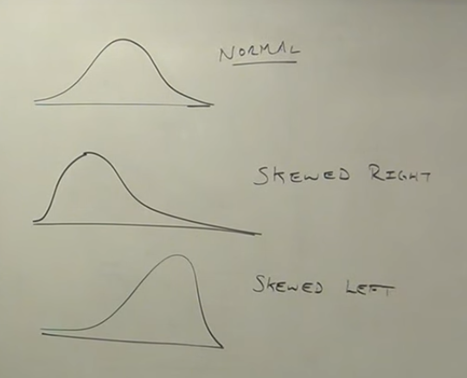
Midpoints
